Jimbo’s Log Kitchen
577 West Dame Avenue
Homerville Georgia
31634
Phone 912-487-2142
E-Mail jlkinc@windstream.net

As a caterer, part of our job is to help you make choices for your event. Catered events can start at food delivered for a backyard tailgate party to a black tie formal. It can also be for a few people, to a thousand guests. Many choices are to be made by you and we are available to help you make those choices so your event is a success and turns out to be everything you desire. Most large events require several companies working together. We have a list of professionals such as venues, florist, linen companies and photographers that can help you complete your event. If you choose Jimbo’s as your caterer, we will help you make sure everything you need is taken care of.

This information should give you a starting point and help you with menu selection. We have composed a list of questions to help you and enable us to give you a better quote.

Name _____________________________________

Event Date _____________________________

Event Location ________________________________________________

Estimated Number of Guest ______________________________________

Estimated Number of Tables & Chairs _______________________________

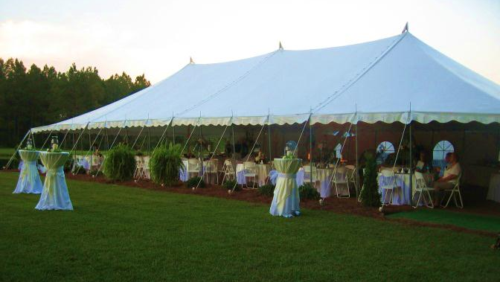

Start Time of event _______________________

Ending time of event ______________________

Menu Selection

Appetizers _________________________________________________________________________

Meats_____________________________________________________________________________

_____________________________________________________________________________

Salads______________________________________________________________________________

______________________________________________________________________________

Vegetables __________________________________________________________________________

______________________________________________________________________________

Beverages___________________________________________________________________________

___________________________________________________________________________

Desserts ____________________________________________________________________________

____________________________________________________________________________

Extras ____________________________________________________________________________

____________________________________________________________________________
Meats
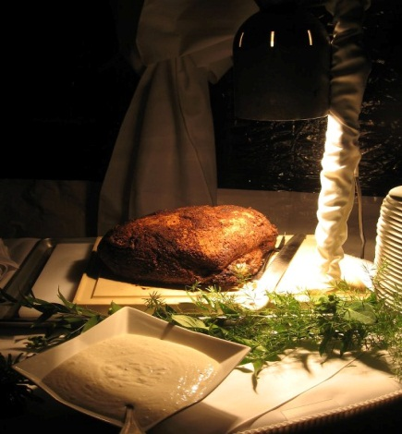
Some meats can be set up with a carving station
Smoked Prime Rib with Horseradish Sauce
Smoked Beef Tenderloin with Horseradish Sauce
Sirloin Roast with Horseradish Sauce
Bacon wrapped Pork Loin with Cranberry Dijon Mustard
Fried Chicken (Regular or Tenders)
Smoked Turkey Breast
Smoked Ham
Pulled Pork with Barbeque Sauce
Bar-B-Que Ribs
Smoked Bar-B-Que Chicken
Whole Smoked Hog
Fried Catfish
Marinated Fried Quail
Fried Gator Tail with Zesty Boom-Boom Sauce
Fried Frog Legs with Swamp Sauce
Boiled Shrimp
Low Country Boil with Shrimp, Red Skin Potatoes, Smoked Sausage and Corn on the Cob
Grilled Chicken Breast with Tomatoes, Onions, Green Peppers, White Sauce and Cheese
Salads
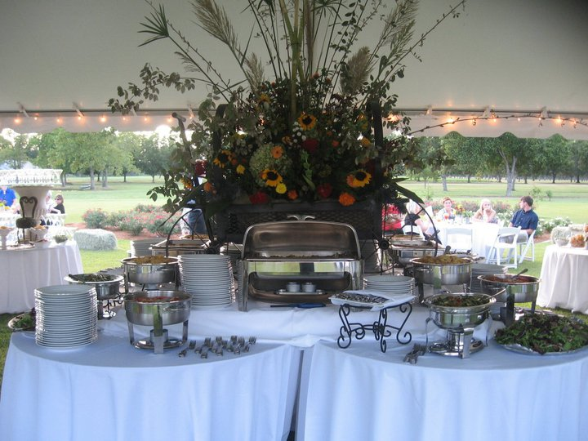
Spring Salad with Apple Dressing
Mixed Greens with Dressings
Pasta Salad
Broccoli Salad
Buttermilk Salad
Grape Salad
Cantaloupe Salad Served with Poppy Seed Dressing
Crab Salad
Shrimp Salad
Smoked Chicken Salad stuffed Plum Tomatoes
Cole Slaw
Potato Salad
Fresh Cut Fruit
Fresh Cut Raw Vegetables
Assorted Cut Cheeses, Assorted Pickles, Olives, Peppers

Vegetables
Fresh Steamed Green Beans with Sundried Tomato and Sliced Almonds
Baked Tomato with Cracked Pepper and fresh Grated Parmesan Cheese
Macaroni & Cheese (I like to do these in glass shooters)
Fried Whole Pod Okra with Ranch Dressing
Twice Baked Red Skin Potato
Green Beans
Squash Casserole
Sweet Potato Casserole
Spinach Stuffed Baby Squash
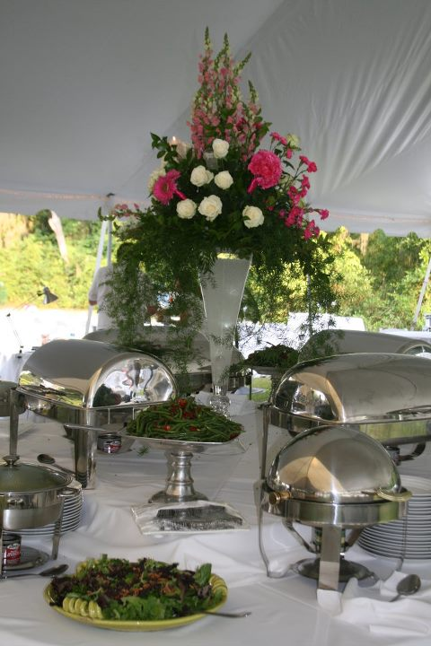
Baked Brown Rice Casserole
Pineapple Casserole
Asparagus Roll-ups
Bacon Wrapped Fresh Green Beans
Marinated Mushrooms
Marinated Asparagus
Pan Fried Black eyed Pea Cakes
Fried Sweet Potato Chips
Cheese Grits
Grilled Corn on the Cob with Honey Mustard Sauce
Brunswick stew

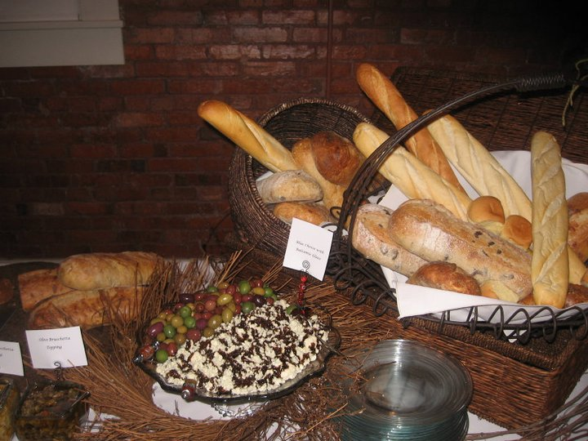
Breads
Assorted Breads
Biscuits with Assorted Jams
Cornbread
Croissants
Hushpuppies

Bars
Mashed Potato Bar
With Whipped Butter, Sour Cream, Bacon, and Green Onion (served in martini glass)
Sweet Potato Bar
with Butter, Cinnamon Sugar, Coconut, Raisins and Pecans (served in martini glass)
Pan Fried Crab Cakes Cooking Station
with Roasted Bell Pepper Sauce
Shrimp & Grits cooking station in Martini Glasses
Toppings Include Cheese, Green Onion and Crumbled Bacon
Pasta Bar
Penne Pasta with Grilled Chicken Served with a Red Sauce, White Sauce, Fresh Basil and Fresh
Parmesan Cheese
Pasta Bar
Veal & Beef Tortellini with Mushroom Marsalis Wine Sauce and Penne Pasta with Grape Tomato’s
Broccoli, Chicken and Alfredo Sauce
Fajita Bar
Beef, Chicken or Shrimp with Sautéed Red, Yellow, Green Peppers and Onion with Salsa, Black
Olives, Sour Cream, Cheese, Lettuce and Tortilla Wraps
Coffee Bar or Hot Chocolate Bar
Includes Assorted Coffee Liqueurs, Whipped Cream, Shaved Chocolate, Cream and Sugar

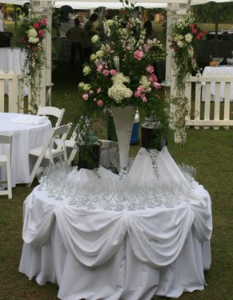

Beverages
Sweet and Unsweetened Tea
Flavored Teas
Fresh Squeezed Lemon Ade
White House Punch
Coffee with Cream and Sugar

Appetizers
Chicken Salad in Philo Cups
Brie Cheese with Apricot Jam and Pecans in Puff Pastry
Spiced Shredded Cheese topped with Strawberry Jam, Served with Water Crackers
Duck Confit with Borsin Cheese and Julienne apples served on Bread Points
Mexican Bean Dip
Artichoke Dip with Triscuits
Cream Cheese Pumpkin Dip with Ginger Wafers
Hot Crab Dip with Water Crackers
Spinach Dip with Corn Chips
Mini Quiche
Cheese Straws
Cocktail Smokies in Sweet Sauce
Meatballs in Mushroom Marsalis Sauce
Tomato Basil Shooters with Lump Crab Meat and Brie Bread Point (can be served in bread bowls)
Shrimp Chowder with Cream Sherry Sauce (can be served in bread bowls)
Smoked Chicken Salad stuffed Plum Tomatoes
Wings Sweet, Spicy or Hot
Skewered Grilled Chicken, Beef, Pork, Shrimp or Chicken
Ceviche
Sliders Buns
Mini Flapjack & Smoked Sausage
Waffle Squares with Fruit Topping & Whipped Cream
Assorted Sushi with Wasabi, Fresh Ginger & Soy Sauce
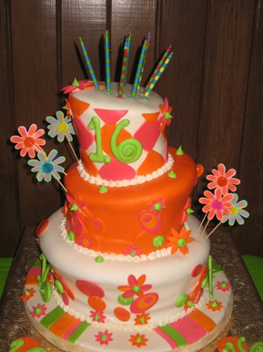
Desserts
Banana Pudding
Chocolate or Lemon Delight
Earthquake Cake
Assorted Dessert Square
Cream Brule
Chocolate Mousse
Spanish Flan with Praline Sauce
Key Lime Cake
Blueberry Bloom Cake
Coconut Cake
Red Velvet Cake
Best Ever Carrot Cake
Butter Cake with Chocolate Cream Cheese Frosting
Chocolate Cake filled with Chocolate Ganash and Covered with Peanut Butter Cream Cheese Frosting
Coconut Cream Pie
Pecan Pie
Key Lime Pie
Wedding Cake
Grooms Cake
Sample Menus

BBQ Pulled Pork, Salad, Corn on the Cob, Brunswick Stew, Hushpuppies, Beverage and Dessert

BBQ Pulled Pork, BBQ Chicken, Potato Salad, Cole Slaw, Baked Beans, Rolls, Beverage, Banana Pudding

Low Country Boil, Spring Salad, Rolls Beverage, Blueberry Bloom Cake

Sirloin Roast with Gravy, Toss Salad, Garlic Mashed Potatoes, Green Beans, Squash Casserole, Rolls,
Beverage and Key Lime Cake

Smoked Chicken Salad, Croissants, Potato Chips, Broccoli Salad, Fresh Cut Fruit, White House Punch

Chicken Breast in White Sauce, Brown Rice, Baked Tomato, Fresh Steamed Green Beans, Rolls,
Beverage, Carrot Cake

Fajita Bar, Mixed Green Salad, Mexican Bean Dip, Grilled Corn on the Cob, Ceviche with Chips,
Beverage, Key Lime Cake

Fried Catfish, Cole Slaw, Cheese Grits, Fried Sweet Potato Fries, Hushpuppies, Beverage,
Chocolate Delight

Shrimp Alfredo with Linguini Pasta, Spring Salad, Baked Tomato, Rolls, Beverage and Dessert

Lasagna, Cesar Salad, Rolls, Beverage and Dessert

Bacon Wrapped Pork Tenderloin with Sundried Tomato Cream Sauce, Spring Salad with Apple Dressing, Brown Rice, Fresh Green Beans, Rolls, Beverage and Dessert

Wild Game – Whole Smoked Hog, Fried Venison, Fried Gator Tail, Fried Frog Legs, Grilled Quail,
Swamp Salad, Cheese Grits, Hushpuppies, Baked Sweet Potato, Whole Pod Fried Okra, Beverage, dessert.

Smoked Sirloin Roast (carving station)
Garlic Mashed Potato& Sweet potato Bar (served in martini glass)
Fresh Cut Fruit
Fresh Steamed Green Beans with Sundried Tomato
Squash Casserole
Assorted Breads
Desserts
Beverage

Smoked Prime Rib with Horseradish Sauce ( carving Station)
Bacon wrapped Pork Loin with Cranberry Dijon Mustard (carving station)
Spring Salad with Apple Dressing
Cantaloupe Salad Served with Poppy Seed Dressing
Twice Baked Red Skin Potato
Fresh Steamed Green Beans with Sundried Tomato and Sliced Almonds
Baked Tomato with Cracked Pepper and fresh Grated Parmesan Cheese
Macaroni & Cheese (I like to do these in glass shooters)
Fried Whole Pod Okra with Ranch Dressing
Shrimp & Grits cooking station in Martini Glasses
Toppings Include Cheese, Green Onion and Crumbled Bacon
Assorted Breads
Wedding Cake
Grooms Cake
Sweet and Unsweetened Tea
Fresh Squeezed Lemon Ade
Water

The sample menus are just examples and can be changed to any combination of items you would like.

For any questions you might have please contact us by phone at 912-487-2142
Or e-mail at jlkinc@windstream.net

Thank you for considering Jimbo’s as your caterer for your upcoming event.

Mark Steedley
Jimbo’s Log Kitchen

